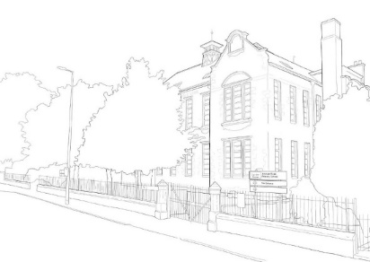

Dear Parent/Carers,

OCTOBER DATES

Wednesday 28th October Halloween Disco
P1-P3 6-7pm
P4-P7 7.15 to 8.15pm

Thursday 29th October
Spooky Dinner from Tayside Contracts
Fire Drill

NOVEMBER DATES

Wednesday 4th November
P1 Trip – Teddy Bear Hospital

Tuesday 10th November
Maths Challenge –Harris P7 (am/pm TBC)
Harris Open evening for Primary 7 pupils
6.30pm to 8.15pm (Harris Academy)

Thursday 12th November and Friday 13th November
In Service Days – Schools Closed

Thursday 19th and Friday 20th November
P1-P4 Childsmile Flouride Varnishings

Saturday 21st November
Harris Cluster Football Competition @ Harris Academy (selected pupils)

Wednesday 25th November
Choir - Lochee Lights Festival and Lights switch on (time TBC)

DECEMBER DATES

Thursday 3rd December
Choir - West End Schools Concert @ Whitehall Theatre (time TBC)

Monday 14th December
P1 Nativity Performance at the School

Tuesday 15th December
AM - Whole School Concert at Lochee Parish Church

Wednesday 16th December
Christmas Lunch and Jumper Day
Christmas Disco P1-P3 and P4- P7
Christmas House event

Wednesday 23rd December
12 noon School closes for holiday
Happy Christmas!

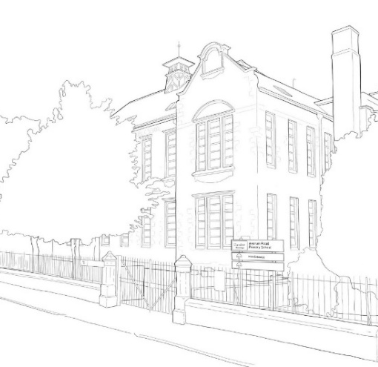

POLITE
PLEASE
THANK YOU
USE NAMES
GOOD MORNING
GOOD AFTERNOON
HELLO and GOODBYE
HOLD DOORS / TIDY UP

PREPARED – READY TO LEARN

LINE UP – PAIR ON A STAIR – BREATHING, WALKING, NO TALKING
USE SAFE HANDS – USE YOUR WORDS
COATS, BAGS, PACKED LUNCHES. WATER BOTTLES
PENCIL, JOTTERS – EQUIPMENT READY
EXAMPLES – SHOWN/KNOW WHAT TO DO
START AS SOON AS POSSIBLE – DON’T GIVE UP

PRODUCTIVE – ACHIEVEMENT
FOLLOW INSTRUCTIONS FIRST TIME
ASK FOR HELP IF STUCK
TEACHERS FEEDBACK ON GAP – HOW CAN I IMPROVE ?
HAVE YOUR SAY

VISION VALUES AIMS AND EXPECTATIONS

OUR VISION – SHINE TOGETHER ACHIEVE RESILIENCE
OUR AIMS – WE LEAD WE LOVE WE LEARN
OUR VALUES - SAFE KIND RESPECTFUL
OUR EXPECTATIONS - POLITE PREPARED PRODUCTIVE

